**Lesson 5: Order of Operations**

**Do Now:**

Each person solved the problem below according to how he/she wanted to solve it. Describe the differences in how each person solved the problem and explain the problem with everyone solving the problem in a different way.

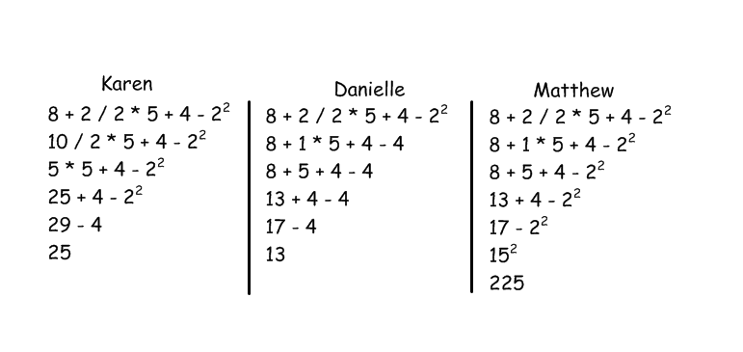

**Karen solved from left to right without paying attention to order of operations. Danielle followed order of operations. Matthew left the exponentiation until the very end. It is problematic if people have different approaches to solving a problem because the answers are different.**

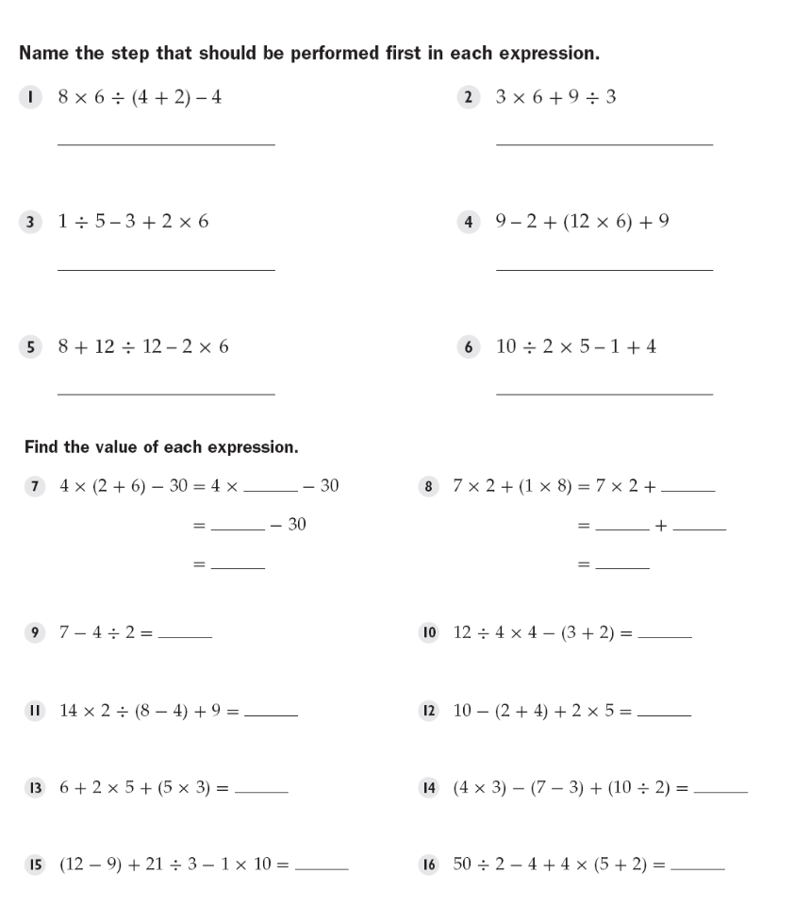

parentheses multiplication

division parentheses

division division

8 8

32 14 8

2 22

5 7

16 14

31 13

0 49

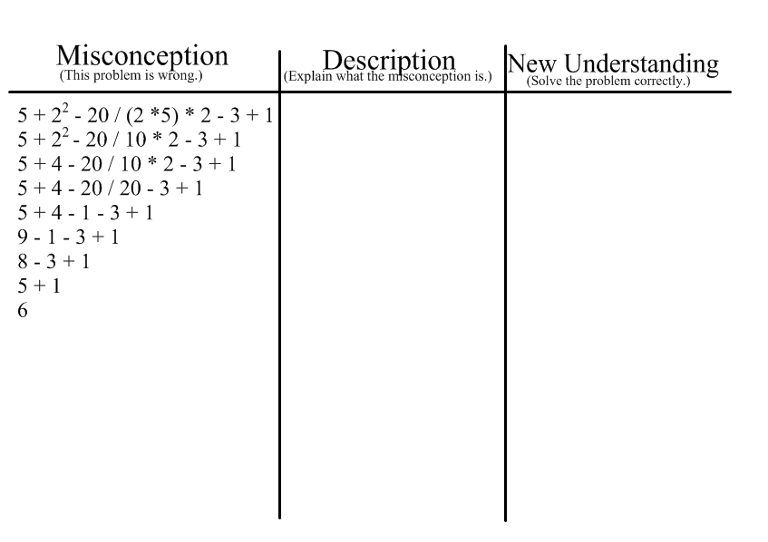

multiplied 10*2 when student

should’ve divided 20/10 first

5+4-2*2-3+1

5+4-4-3+1

3

**Structured/Guided Practice:**

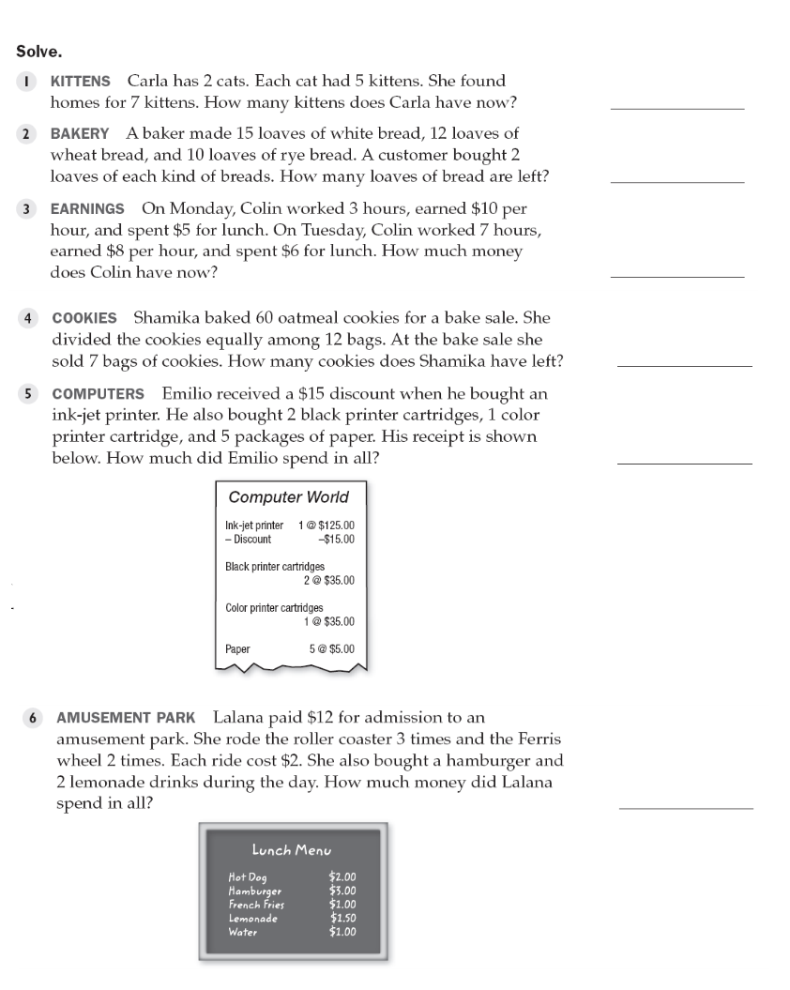

3

31

$75

25

$240

$28

**Independent Practice:**

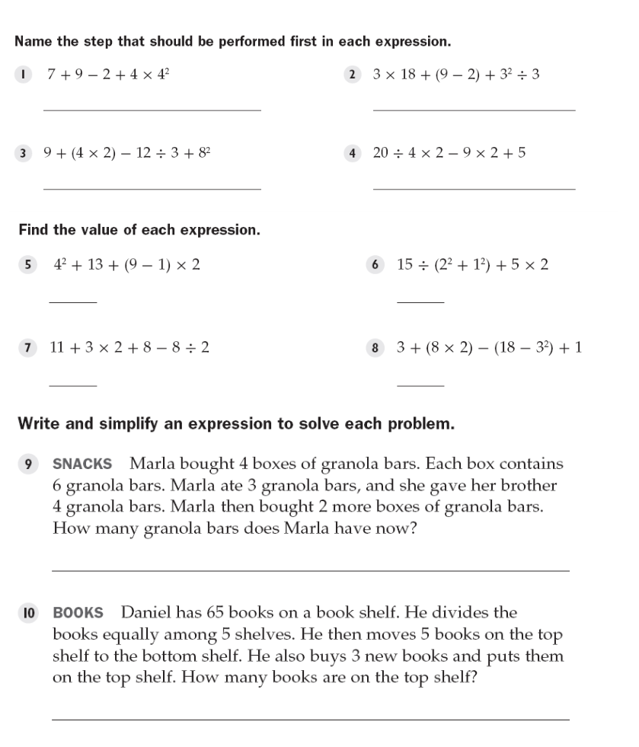

exponentiation parentheses

parentheses division

45 13

21 11

29

11